SHIVGADHI ENGLISH SCHOOL
Shivraj-1, Kapilvastu
2nd Terminal Examination 2081
Class: 8 Set -B F.M. 50
Subject: Science
Attempt all the questions:
- Multiple choice questions. 10
a. What is done first when studying science ?
i. Research ii. observation iii. Test iv. Use
b. What is the full form of URL ?
i. Universe Resource Locator ii. Universal Rescue Locator
iii. Universal Resource Location iv. Universal Resource Locator
c. In which form is the energy generated in a cell stored before is it distributed to organelles ?
i. DNA ii. RNA iii. ATP iv. RBC
d. Where was the world Earth summit on biodiversity held in 1992 AD?
i. China ii. Brazil iii. Japan iv. Africa
e. What percentage of plant species of the world is found in Nepal ?
i. 1.1% ii. 10% iii. 3.2% iv. 0.1%
f. Which of the given organism reproduces by regeneration ?
i. Plasmodium ii. Bacteria iii. Amobea iv. Planaria
g. Which of the following is the group organisms that reproduces sexually ?
i. Amoeba , mango ,bird ii. Fish , butterfly , mustard
iii. Amoeba , tapeworm , hydra iv. Frog , liver fluke , bryophyllum
h. What is the SI unit of Force?
i. J ii. W iii. N iv. Pa
i. On which principle is a physical balance based?
i.ExLd=LxEd ii. EXEd= LxLd iii. EdxLxE iv. MAxE=MAxL
j. What is the atmospheric pressure at sea level ?
i. 760mmHg ii. 700mmHg iii. 750 mmHg iv. 1000mmHg
Group B
Very short answer questions . 8x1=8
a. What is cytology ?
b. Write the types of lever.

c. What is sustainable development?
d. What is biodiversity?
e. What is pollination ?
f. How many types of reproduction are there ? Name them .
g. What is an ideal machine ?
h. What is the formula to calculate liquid pressure?
Group C
Short answer questions 8x2=16
a. Write the full form of
i. ATM ii. WiFi
b. Write two differences between self pollination and cross pollination.
c. Name the five kingdoms and give an example of each.
d. Write two differences between in-situ conversation and ex-situ conservation .
e. Write the type of asexual reproduction occur in following Organisms .
i. Amoeba ii. Hydra iii. Potato iv. Mushroom
f. Prove P=dhg
g. What is efficiency of machine? The mechanical advantage of
machine is 4. What does it mean?
h. Two cars A and B start to move from a reference point in opposite directions with the velocity of 20m/s and 6m/s respectively.
Calculate the relative velocity of car A with respect to car B . What will
be the velocity of car A relative to car B if they move in same direction?
Group D
Long answer questions 4x4=16
a. What is acceleration? Write its formula. A bus starts from rest. If
the acceleration is 2m/$s^{2}$, calculate the velocity of the bus after 2
second. Calculate the average velocity of the bus.
b. What is lever? An effort of 150N is required to lift a load of 400N.
If effort cover 7.5m distance then calculate mechanical advantage,
Velocity ratio and efficiency .
c. What is Social media? Give examples. Write any two advantages of
social media. Write two disadvantages of social media.

d. Study the given diagram and answer the following questions .
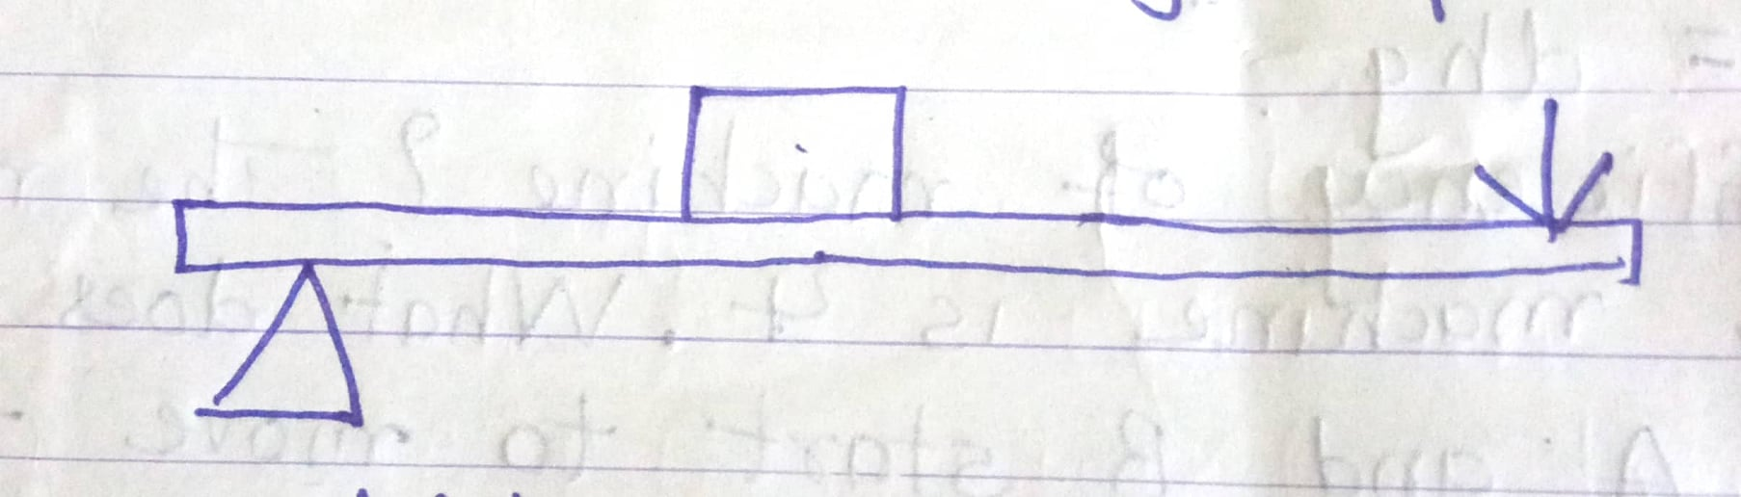

i. Which class lever is this?
ii. Write a use of it.
iii. Write two examples of this lever.
iv. What class of lever will it be if load and fulcrum are interchanged?
Best of Luck

